**Line Graph**

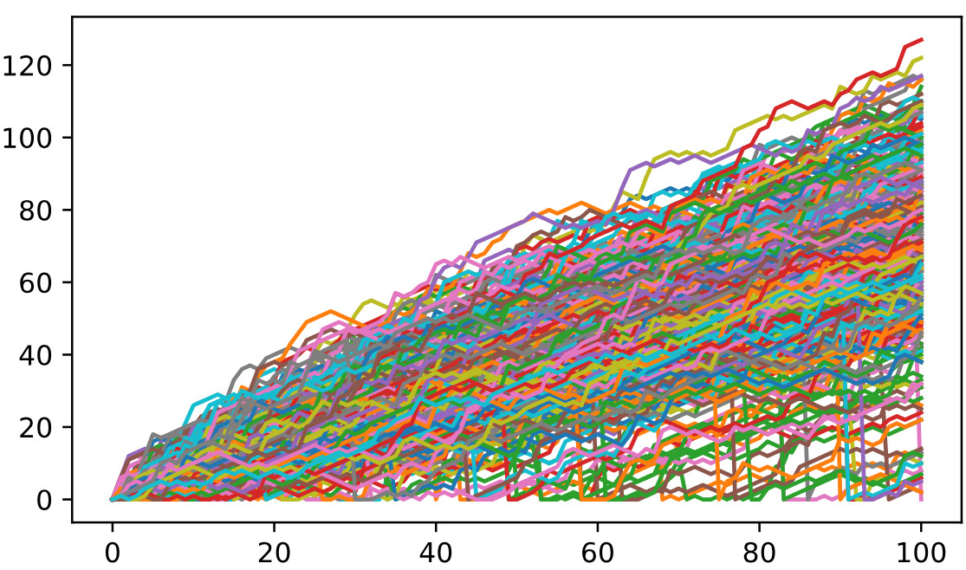

The line graph Indicates the number of steps reached after the 500 simulations of 100 random walks are completed.

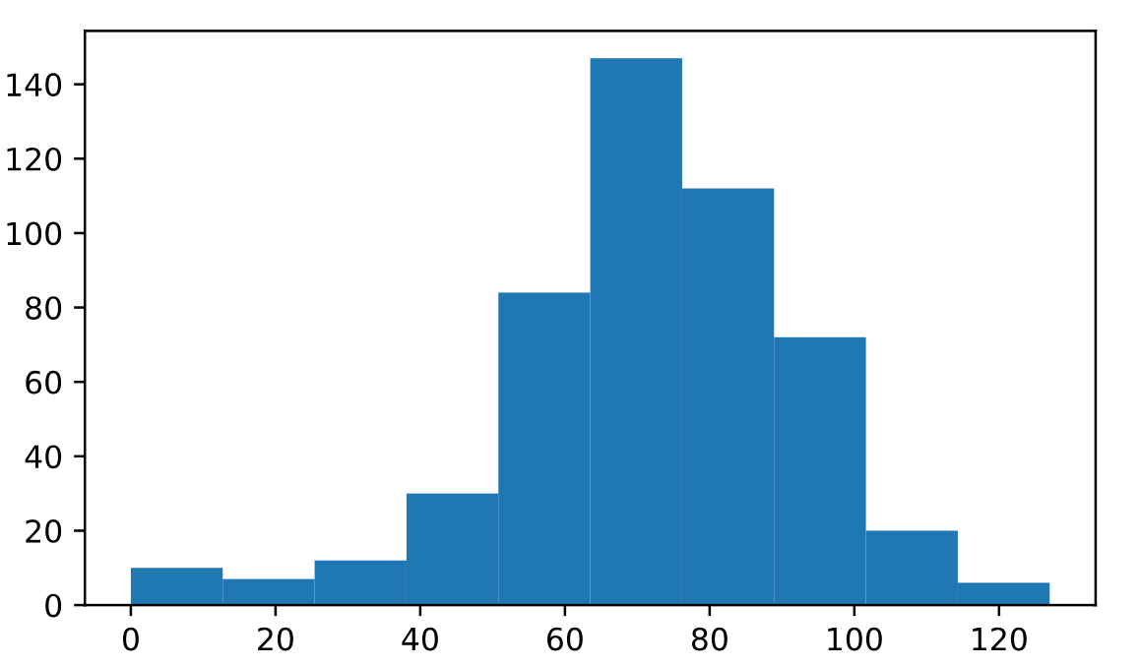

The histogram indicates the distribution of the number of steps reached after the 500 simulations of 100 random walks are completed.